

**D.Y. PATIL COLLEGE OF ENGINEERING &TECHNOLOGY, KASABA BAWADA, KOLHAPUR**

DEPARTMENT OF COMPUTER SCIENCE & ENGINEERING

(Academic Year: 2024-25)

**REPORT**

On

**“Chat App”**

# Submitted By:

**Roll No. Name**

38 Mr. Chaitanya Rajendra Teke

Under the Guidance of:

# Prof. A. S. Yadav

Class: **B. Tech (CSE)** Div.: **“B”** Batch: **B2.**

**Index**

|  |  |  |
| --- | --- | --- |
| **Sr.no** | **Chapter** | **Pg.no** |
| 1 | Introduction | 3 |
| 2 | Problem Statement | 3 |
| 3 | Objectives | 3 |
| 4 | Proposed System Architecture | 3 |
| 5 | Implementation | 4 |
| 6 | Conclusion | 4 |

**Introduction**

This report outlines the development of a real-time chat application designed for seamless communication in specific chat rooms. The project utilizes React.js for the front end, Node.js and Socket.IO for real-time backend communication, and MongoDB for persistent message storage. Key features include real-time messaging, message deletion (marked as deleted in the database), and an intuitive user interface. The application demonstrates the effective integration of modern technologies to deliver a scalable, interactive, and user-friendly chat platform.

**Problem description:**

Effective communication is essential, yet many chat applications lack real-time updates, intuitive interfaces, and efficient message management for group-specific interactions. This project addresses these challenges by creating a real-time chat app with room-based messaging, easy message handling, and a seamless user experience.

**Objective:**

The objective of this project is to develop a real-time chat application that enables users to:

1. Communicate seamlessly within room-based environments.
2. Send, receive, and manage messages efficiently.
3. Provide intuitive features like message deletion while ensuring robust data management.
4. Enhance user experience with visually appealing design and real-time updates.

**Proposed System Architecture:**

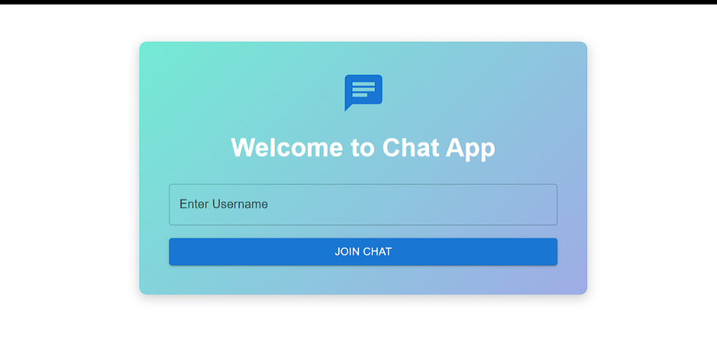**Implementation:**

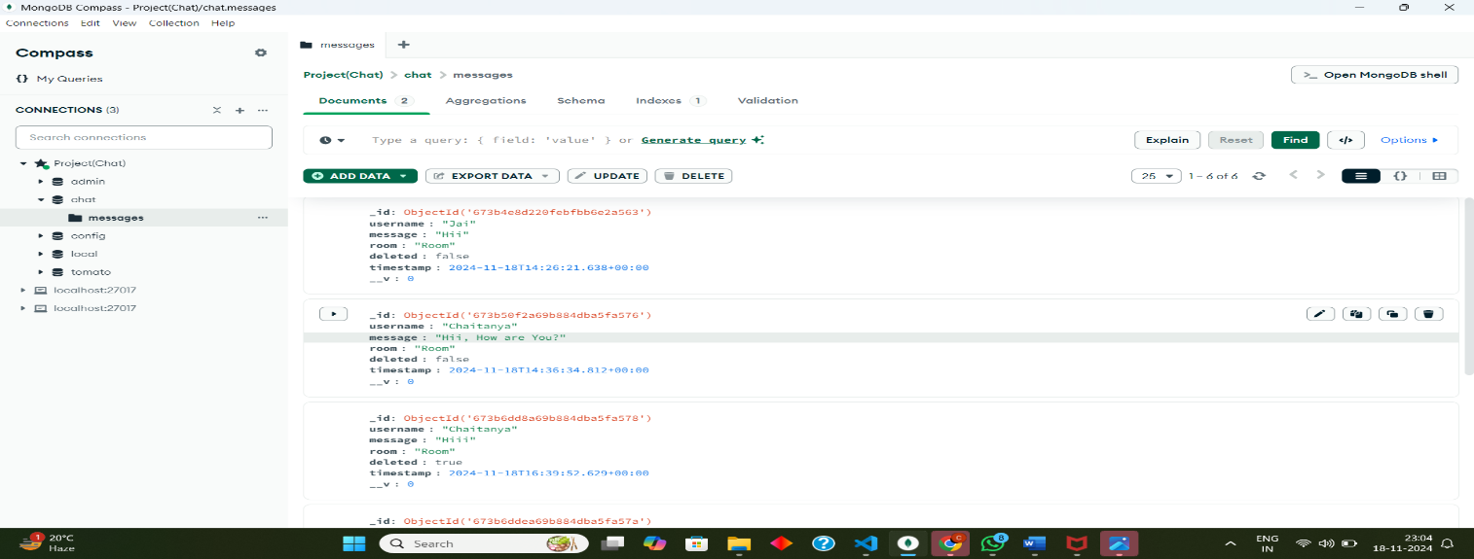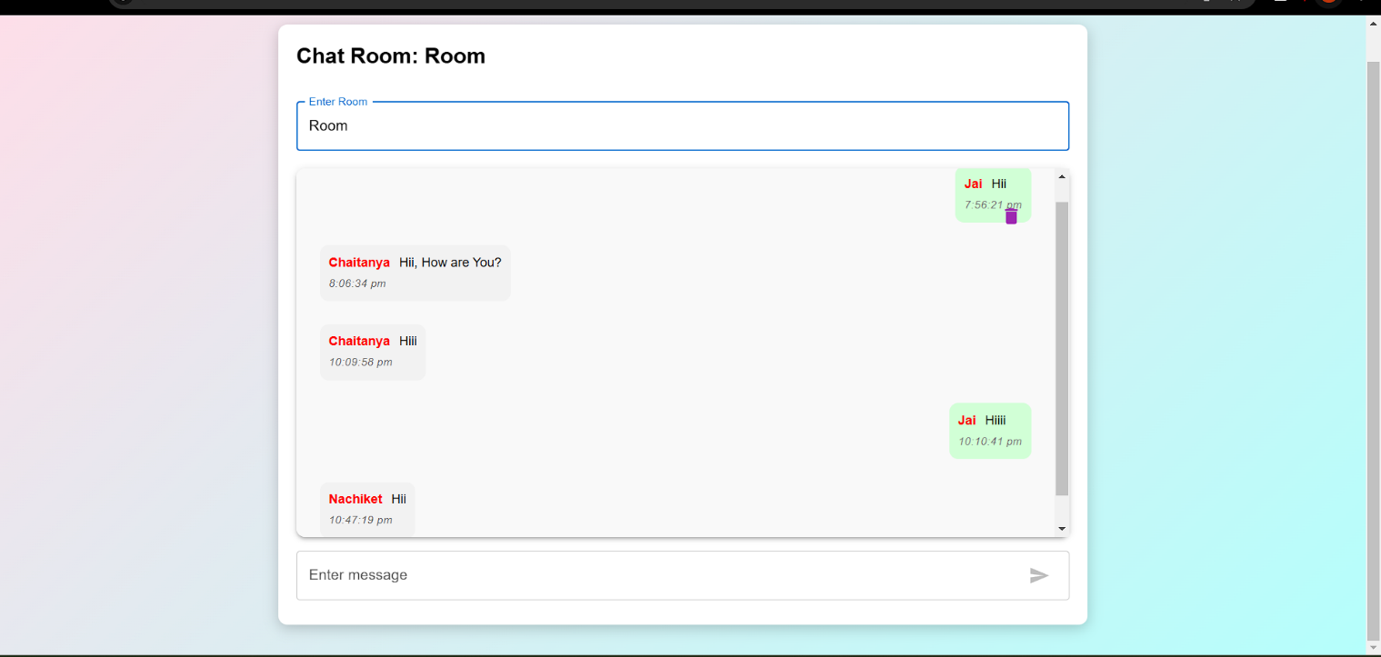

**Conclusion:**

Developing a chat application using the MERN (MongoDB, Express.js, React.js, Node.js) stack offers an efficient and scalable solution for real-time communication. By leveraging the strengths of the MERN stack